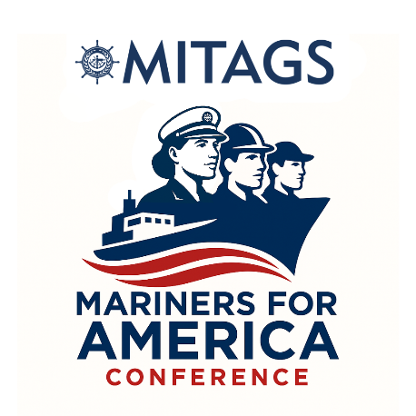
Exploring strategies for supporting the future of Mariner Recruitment,
Development, and Wellbeing.

March 30 – April 1, 2026
Linthicum Heights, Maryland

Agenda is Subject to Change
DAY ONE
Attracting the Next Generation of Mariners
Welcome Remarks
Why Become a Mariner?
Recruiting Strategies
Welcome Reception
DAY TWO
Mariner Career Development
Learning for Compliance, Proficiency, and Advancement
Skills for the Future Mariner
Networking Break
Paying for Training
Lunch
Mentorship
Soft Skills for Hard Cases
Networking Break
Coming Ashore: When, How, and Why
Dinner with Guest Speaker
DAY THREE
Mariner Well Being
Mariner Mental Health
Employee Engagement
Networking Break
Work Life Balance
Closing Remarks

